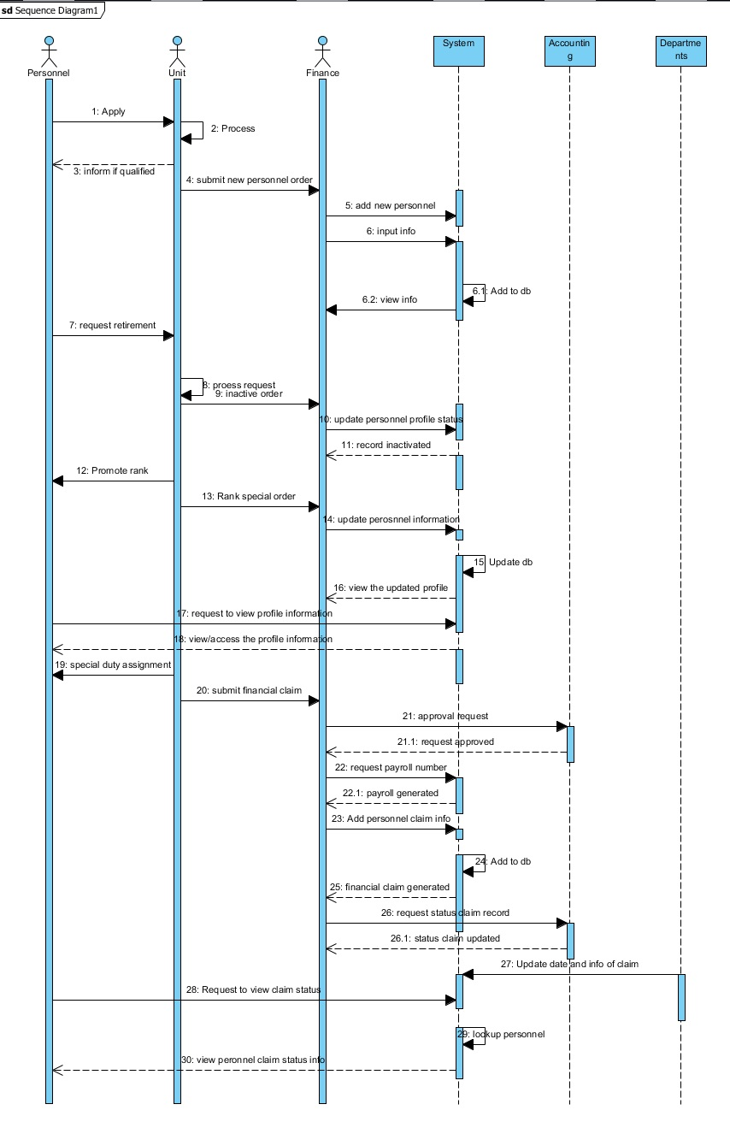

**SEQUENCE DIAGRAM**

**COMMUNICATION DIAGRAM**